**Chess Opening App**

Statement of Purpose

Title: Openings App

Purpose: Allows players to read up on chess openings before they start playing or for new players to learn chess openings

Runtime Environment

Mobile

Info Needed

Email

Password

First Name

Last Name

Class Design

**User (Class)**

String firstName

String lastName

String userEmail

String userPassword

**Openings (Class)**

Int[] numericalOrder

String openingName

Bool frequentlyUsed

**Types(class)**

? Opening game

? Mid game

? End game

**Difficulties (Class)**

Enum ez

Enum med

Enum advanced

Features

**Search openings**

**Filter openings**

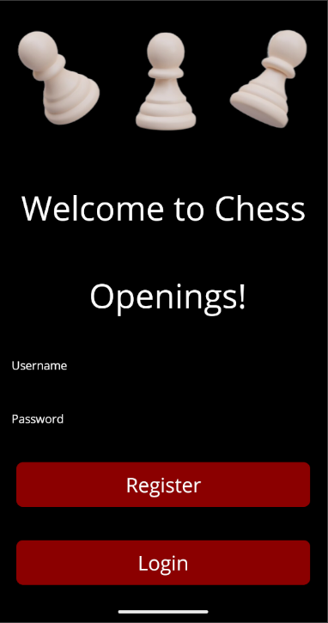

Main Page

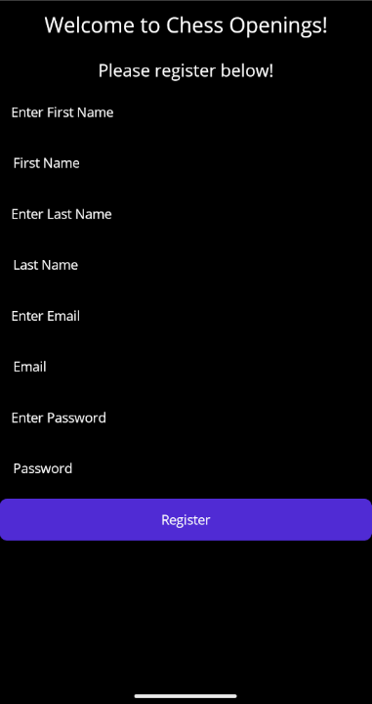

Register Page

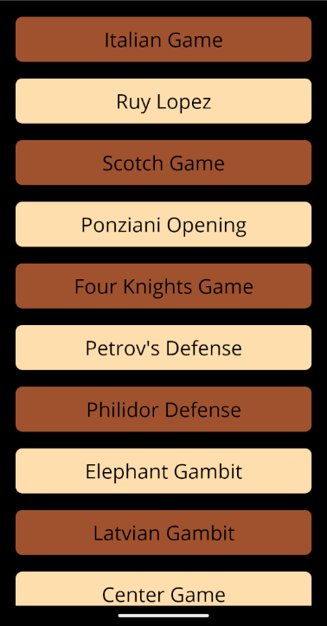

Post Logon

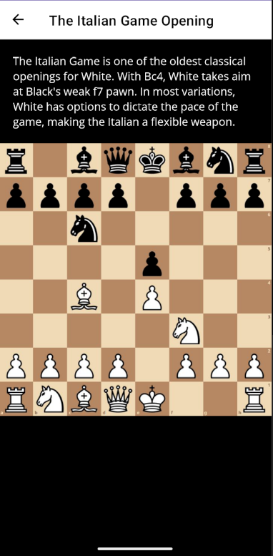

Opening Info

Animation?